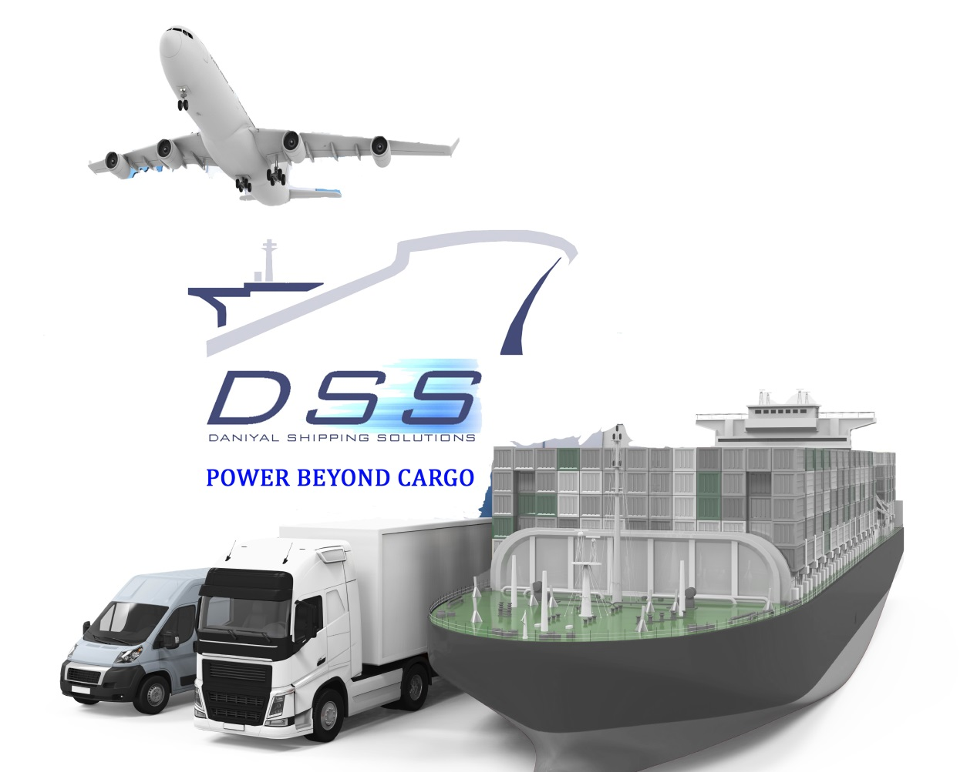

Feel free to contact us
Building#3, W12
Dubai Business Park,
Dubai World Central.
+971 48879925
info@Daniyalshipping.com

Worldwide freight
Daniyal Shipping helps in improving the supply chain of distribution to international/regional/domestic market by using different modes of transport, i.e. land, ocean and air freight, along with the combination of more than single mode of transport for shipment of your goods in economical and efficient way.

Warehousing & Logistics solution
Daniyal Shipping provides smart and efficient warehousing solution. DSS offers complete warehouse operation with domestic distribution for all industry within GCC and UAE.
Contract Logistics for short term, long term, and project based warehousing operation at our own facility in Dubai Logistics City (Jebel Ali).

With the rising needs of such insatiable market we have been fortunate enough to have all the necessary tools & skills to compete on par with others by not only keeping competitive cost but also providing the best services. We are proud to have accomplished our objectives so far and always strive to move forward.

DSS offers the following services:
- Sea Cargo & Air Cargo
- Transportation
- Consolidation
- Warehousing & Stuffing
- Loading / Lashing
- Clearing & Forwarding
- Import & Export handling
- Local & GCC transportation
- Handling Project Cargo
- Door to Door Service

We strongly represent a wide network of partners and agents spread across the major part of the world enabling us to offer services to all the major Sea Ports/Air Ports, which can offer high quality personified and exceptional forwarding services.

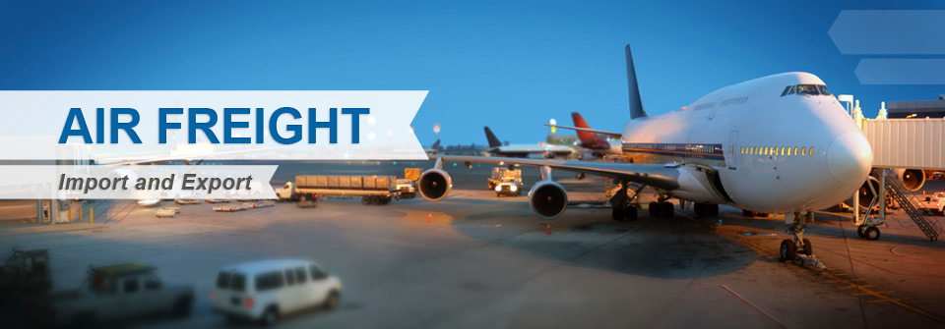

AIR FREIGHT
DSS offers you reliable air freight services for all your high priority consignments through sophisticated and innovative Air services tailored to the customer needs.
Our airfreight products encompass a complete range of advanced, high quality services provided globally. Our experience in scheduling and clearance procedures combined with our network offices and selection of premium airfreight carriers, affords maximum presence with optimum connections thus enabling our customers to save time and money.
DSS offers extraordinary and reliable door-to-door and port-to-port air cargo services. We also provide multiple airline options to the manufacturers and suppliers either direct or transshipped for import and export shipments. Airport to airport transits are also offered for maximum customer satisfaction.
.
Air-freight Services Offered Includes:
- Air Freight (Export / Import)
- Air Consolidation
- Projects Cargo handling
- Perishable Cargo Handling
- Ship Spares movement
- Aircraft Chartering
- Customs Clearing and Forwarding

OCEAN FREIGHT
DSS offers a complete range of sea freight services for all types of cargo requirement. We can offer a flexible range of Ocean Freight services for both Less-Than-Container Load (LCL) and Full-Container Load (FCL) shipments. These are backed by comprehensive Ocean Freight Management Services as well as Break-bulk, Project Forwarding, etc.
We also offer a vast choice of destinations from every major port in the world across both intercontinental and short sea routes to accommodate your needs.
With an extensive experience in clearance procedures, planning & scheduling combined with our network of owned and agency offices and a selection of premium sea freight carriers, enables us to deliver to the complex needs of our customers efficiently and cost effectively.

SEA-freight Services Offered Include:
- Full Container Load SERVICE (FCL)
- Less Than Container Load SERVICE (LCL)
- Project Cargo (oversized / non-containerized)
- Sea-Air SERVICE
- Multi-Modal Service
- Break Bulk
- Consolidation
- Customs Clearing and Forwarding
- Documentation Preparation

LAND TRANSPORTATION
DSS has set high quality standards for direct deliveries with-in the entire middle-east region, with assistance of best transport network. We provide a full scope of transport solutions from consolidation trucks up to complex truck movements for specialized cargo. We can manage any kind of cargo from the smallest, most fragile or hazardous and project cargo.
We offer Land Transportation in all major G.C.C. & Middle East countries from & to UAE (Dubai, Sharjah, Abu Dhabi, Jabel Ali), Oman, Kuwait, Doha, Bahrain, Saudi Arabia (Jeddah, Dammam, Riyadh), Jordan, Iraq, and other places by low bed, long bed curtain type and box type refrigerated trailers by road.

INTELLIGENT WAREHOUSE SOLUTIONS
DSS as a Cargo Warehousing Agent provides high level professional warehousing services and care that is the assurance of the safe arrival of your product anywhere, anytime. Through our integrated inventory management system, DSS can not only provide control on a worldwide basis but also allow customers to supplement and redistribute cargo. This approach reduces cycle time while assuring constant availability of product. We at DSS offer special warehousing facilities for containerized, refrigerated and hazardous materials & related services such as consolidation, re-packing, documentation, labeling, invoicing & distribution at our own facility in Dubai Logistics City (Jebel Ali).
.
- Adequate insured private warehousing space
- Warehouse space at the ICD's for storage of goods carted direct at these centers
- Safe storage of goods
- Control checks on entry & exit of goods
- Helps our clients to reduce fixed overheads, increase efficiency, cut down valuable management time and offer great efficiency

