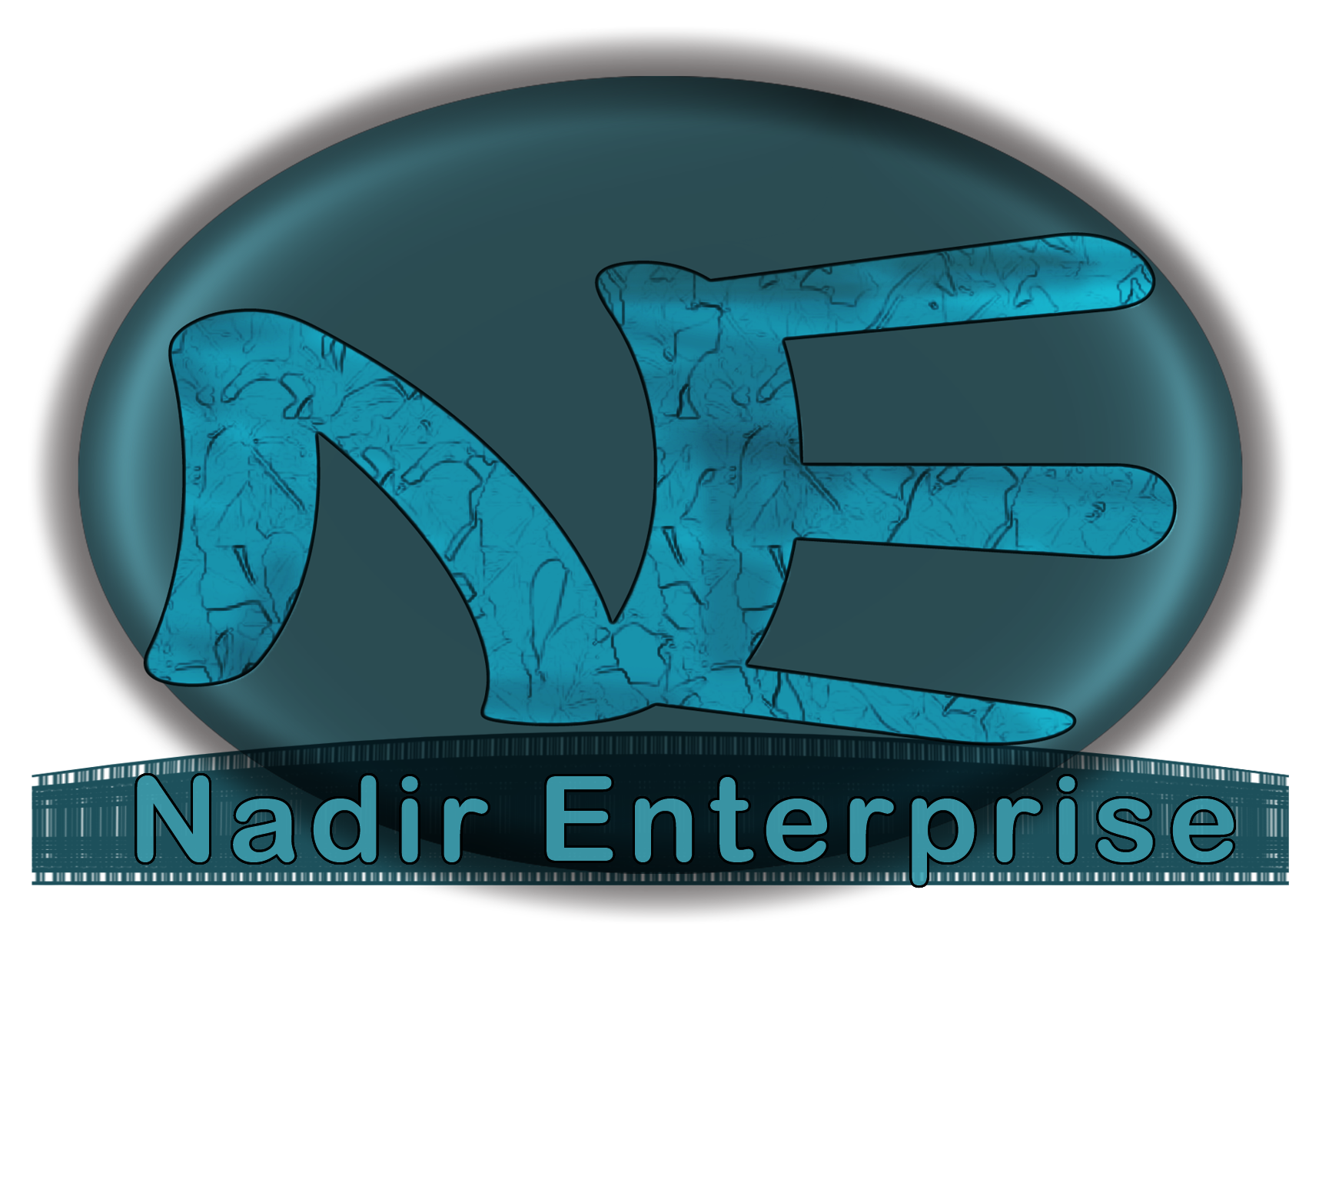

ABOUT

Nadir Enterprise is a professional video production, graphic design, and multimedia production facility dedicated to bringing you the most exciting media products. Nadir Enterprise Productions creates a wide assortment of marketing materials – from professional video programs for broadcast or cable television. We even bring your Voice or Message to the audience of the twenty-first century by producing interactive Digital Music

Our video production and editing department is equipped with state of the art broadcast quality video editing systems, which include the Media 100 and a network of Silicon Graphics workstations. This equipment powers the latest 3D computer modeling, animation, and video effects software, creating unsurpassed effects for any production. Nadir Enterprise creates corporate overviews, training tapes, documentaries, commercials, or any type of program you may need. Our staff will skillfully walk you through all stages of production from concept development and script writing to shooting and editing of your finished program.

The most successful individuals or enterprises are those that seek and maintain long-term relations with all of their vendors. We find this to be true. We suspect you do as well.

